Transition to Online Learning

The purpose of this guide is to provide staff with practical points on designing and delivering online sessions, with a particular focus on transition to online learning next week. Staff can scan through the whole document or pick and choose from any session. This will be a live document and new content will be added in due course.

Contents
1.0 Welcome & orientation to students to new ways of doing 2
2.0 Establishing Expectations 2
3.0 Feedback Strategy for Online Learning 3
4.0 Discussion Forum to Enhance Student Engagement 3
5.0 Learning & Teaching Strategies 4
Appendix 1: Student Engagement - Warm Up/Fun Activities 6
Appendix 2: Top Tips for Online Learning 7

1.0 Welcome & orientation to students to new ways of doing

- Welcome video: In preparation to online teaching next week it is important to consider a welcome video to make it personable for the students. Create a welcome message designed to calm your students’ fears and let them know that you are committed to their continued success. In the first instance reassure the students and emphasise that we are trying to ensure that they will meet with the programme requirements.

- Communication strategy: Be sure to include how to best communicate with the module team – this has to be contextualised to your module. Reassure students that you are there to help them and they should not hesitate to reach out to you. It might be the same approach to communication pre-crisis – the only thing that might change in the mode of communication, i.e. emails, skype, WhatsApp, etc.

- Timetable: Communicate the timetable of the revised session – please be aware of the different time zones your students might be.

- Additional videos: Details of the NEW online learning and teaching approaches and assessment can go on in two separate videos/narrated PowerPoints. Share how you intend to support them in the course and include any directions or resources students will need to get started.

- Recording yourself: Your videos can be very informal and creative. Use your webcam or smartphone. Try to choose a relatively quiet place with good lighting. If recording on your smartphone, consider using a tripod to keep a steady, centred frame. To make the video more personal, you may also want to record in a fun or relevant setting. Use PowerPoint to easily record voice-over narration to slides. You can get creative and show engaging visuals and/or examples of your work.

2.0 Establishing Expectations

- Pilot online learning activity: When rolling out the online sessions consider a ‘pilot’ on the first day to check out if it’s feasible. Highly recommend the first session to be asynchronous to ensure it is glitch free. There might be technological challenges for staff and students and we do not want multiple issues on the first 2 days of online teaching. Suggestion: Consider a 1-1-1 strategy for pilots – 1 learning objective, 1 online resource/video, 1 activity for student to complete.

- Students travelling: Based on point 1 – please remember that students will still be travelling over the weekend back to their countries. The university email clearly stated that online teaching will commence on Monday 23rd, therefore any activities prior to that should be just information, guidance or directed activities.

- Keep videos simple: Make videos that are on purpose very easy, home-made, no high-tech, nothing too 'fancy'. To model what academics can realistically produce at this point in time, and to highlight that the ideas matter more than the technology.

- Student engagement: Consider the student experience when designing online sessions. Think about student engagement activities – especially on the first day. Please see Appendix 1 titled ‘Student Engagement activities’ – which has multiple examples on how this can be done.

- Staff availability: Module team members need to be clear on communicating your online time schedule (UK time) – when you will be online. This will help in supporting student for synchronous meeting or for pastoral support. Be specific on when you will be available for discussion board or group activities for facilitation. AGAIN – be clear it will be UK time and be considerate of the different time zones.

- Responding to questions: Establish the timeline by which you will respond to their questions/queries. This will depend on workload, personal circumstances and part time nature of staff. However, any clarity will help meet students’ expectations.

- Ongoing communications: Finally consider the weekly patterns that students should follow to be successful in your module—for example, “Each Monday, you will receive the recorded videos/microlecture and learning activities. Each Wednesday, you should participate in the online discussion. Every other Friday, you should submit your reflection paper.” Let students know where in the module they can find the weekly schedule.

3.0 Feedback Strategy for Online Learning

This guidance is for ongoing feedback in terms of facilitation of learning. Guidance on summative feedback for (alternative) assessments will be included in the updated assessment handbook.
- Managing student expectations: Students will be looking for tutors to be involved in discussions, respond to questions, provide feedback and encouragement, and reach out when you notice they may need additional assistance. This does not mean that you need to be online 24/7.

- Individual feedback: Students are usually anxious to receive feedback on their work, so setting and meeting expectations for when they can expect feedback will help them to manage their expectations.

- Feedback methods: If possible be clear on the different methods of feedback the students going to receive – group versus individual; is it going to be weekly – through emails, individual skype etc. If there are multiple strands, consider staggered feedback over days or weeks.

- Receiving feedback from students: Consider a strategy on asking feedback from students on how online delivery went. This will shape the engagement and understand their experience and identify strategies to enhance future delivery. Suggestion: the first feedback could be at the end of the pilot session. Following that at 2 more instances in the first week. Depending on the issues raised revise the frequency in which you gather feedback.

4.0 Discussion Forum to Enhance Student Engagement

- Creating sense of belonging: Consider strategies for fostering a sense of community (online Communities of Practice). Active participation in a community of practice is a social process, and yet it enhances individuals’ learning and can also increase their social capital through developing connections and recognition.

- Continuing sense of belonging: Think about steps to keep them together and engaged. Suggestion: This might involve reminding them of what they are supposed to be working on at any given moment, or fostering a sense of community between the learners by making yourself a key part of that community. Drawing on the concept of communities of practice, you could emphasise that connecting and sharing with like-minded others can be very beneficial.

- Role of tutor in an online environment: The role of the tutor needs to become more supportive and collegiate, such that the learners understand that your primary role is to help them to succeed on the module. To this end, it can be useful to construct an individual relationship with each learner (if possible! Or at least at risk learners) rather than always relying on mass or automated emails.

- Methods of connecting: In face-to-face classes, students naturally connect with you and with their peers. These interactions often include asking and answering questions about the course. You can continue to encourage these interactions in an online course by creating a question-and-answer forum in which students can post general questions about the course and assignments. Padlet is often used – but consider if this will still be your strategy of you want peer interaction.

- Discussion forums: You can also create a separate, informal social space for student-to-student interactions. Consider sending an email to your students introducing the forums and describing their different purposes. See below for a sample email.

Dear students,

I know that the switch to online classes can feel a little isolating. You and your fellow students are used to chatting before and after class. During these conversations, or even when you meet a fellow classmate or me around campus, you may ask us a quick question about the course. Going online means we will miss these informal interactions.

To make up for this, I have set up two discussion forums in the course. One is called “Online Office Hours,” and the other is the “Class Café.” I invite you to post questions you have about the course to Online Office Hours, which I will monitor regularly to respond to your questions. You can also review the posts to see if your question has already been asked and answered. I also invite you to connect with your classmates in the Class Café forum! Please let me know if you have any questions at all! I am here to support your work and to ensure that your learning is not interrupted.

Best wishes,

5.0 Learning & Teaching Strategies

- Modes of teaching: Consider synchronous and asynchronous modes of teaching. More asynchronous during transition next week.

- Facilitation of online learning: It is important to note that supporting learners in an online environment requires a different skillset to supporting learners in a face-to-face learning environment. Consider cohort strategy and also individual student strategy. Accessibility guides are available in Microsoft Teams.

- Role of tutor: The differences between learner perceptions of teaching in an online environment and in a face-to-face environment is that the online tutor should have a greater pastoral focus than that of a face-to-face teacher, and that often both teachers and learners needed guidance and training in communicating online. Without the ‘comfort’ of a physical classroom environment, learners can feel isolated and unsupported, so an increased pastoral presence by the tutor, initiated via online communications, can help reduce that feeling of isolation and develop a more ‘comfortable’ experience for the learner.

- Sustaining motivation & attention: Keeping learners motivated and attentive online can be much more challenging than in a face-to-face environment where your personal enthusiasm for the subject can readily rub off on the learners. In an online environment, you will likely have learners who are more self-motivated, learners who are more comfortable with online learning, and learners who are less certain of how to interact. There might be particular challenges for those learners who are less capable of structuring their studies independently. Potential solution: It is worth providing a highly structured set of tasks in the opening stages of the course, with discrete outputs, which enable you to see very quickly which learners are completing the tasks on schedule and in the manner that you desire. You can then follow up individually with those who are not engaging in the expected manner and offer advice on how they should approach the tasks and their online learning experience.

- At risk students: If a learner is unusually reticent in an online session, or doesn’t post to a discussion thread which you would have expected them to engage in, it can be worth tactfully exploring with the learner (in private, of course) to ascertain what has caused the change in their interaction/ behaviour online. Please be mindful of evolving mental health issues.

- Identify & document technical issues: You also need to be aware of the complexities that technology may bring. Whilst it is not usually necessary to become a technical expert, familiarity with the common technical issues your learners may face can be a very useful skillset to develop.
Action: A department shared document will be set up for staff to add (a) the technical issues they face and (b) the technical issues encountered by the students on their end. This will help share the challenges across the programme teams

- Adapting flipped classroom approach: Most staff are familiar with flipped classrooms – in essence you can use the same strategies for online delivery of each session.

Appendix 1: Student Engagement - Warm Up/Fun Activities

Please be aware of student experience and mental health during transition to online learning particularly next week and more so in the weeks after. Students will be understandable stressed and anxious on their physical, social, psychological and financial health. Therefore, try and balance with other fun activities that enhances students’ engagement. This is a great opportunity to be creative.

These are some ideas/suggestion to have some fun, build group dynamics, and try to help people keep OK. Perhaps a different activity each week?

- Getting everyone to check in with everyone else and acknowledging emotions, feelings, wobbliness: obviously with this it is important acknowledge everyone’s status and have a way of checking and supporting people who are not OK.
  - choose an emoticon for you today (see emotion pictures below as examples)
  - choose from a set of pictures about how you are
  - write a word on the virtual whiteboard / discussion board that reflects how you feel
- Share a picture of where you are working, with a prize for best caption
- Share a picture of where you’d like to be working (beach, forest, mountain top)
- It’s behind you! – what is behind your head on the monitor?
- Share a picture of your book shelf with recommendation for one of the books
- Pictures of pets (or pets you wish you had) and match names to pets and people.
- View out of your window or your imaginary best view out of your window (might be tricky as things progress?)
- What am I not missing about university? Post a picture – be careful not to include people! (for me this would be a picture of a crowded train)
- Background noises: get students to guess what the background noises or interruptions are. E.g. dogs (can guess the dog’s name); deliveries (what’s in the parcel? If not too embarrassing).
- Group name/ ‘superhero’ motto/ mascot: Group mascot could be one of your pets; group name could be something you all have in common in terms of work space; group motto can be subject-related, but phrased in superhero speak (e.g. for my PG CAP students it could be ‘fighting to make practice reflective!’) - keep it light hearted and inclusive
- Cartoon of the week: is there a subject related cartoon that different members of the group could share before each session. Take it in turns (might need some monitoring?)
- Focusing on the positive: share a picture of an object that made you happy, positive, laugh etc. from the day (might need some care for some participants)

Appendix 2: Top Tips for Online Learning

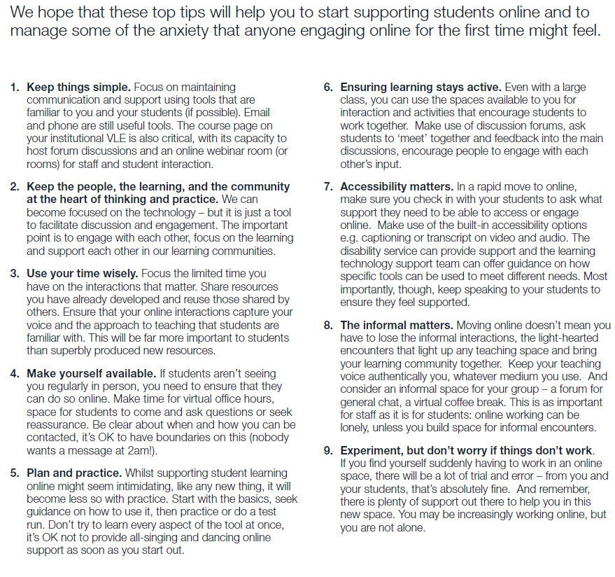

Acknowledgements
Top tips adapted from Heriot Watt University guidance.
The reminder of the document was from various resources from the OPEN University and Association of College and University Educators.
Student Engagement activities was adapted from Sian Etherington (Salford University)

